ECE 3355 – ELECTRONICS
HOMEWORK #5

Sedra and Smith 8th Ed., Chapter 2: Problems 2.9, 2.32
Problems E5.1, E5.2, E5.3, E5.4. These problems are given below. They are not extra problems; they are exercises.

E5.1 Find the gain, v_{out}/v_{in}, of the following circuits, assuming ideal op amps.
- 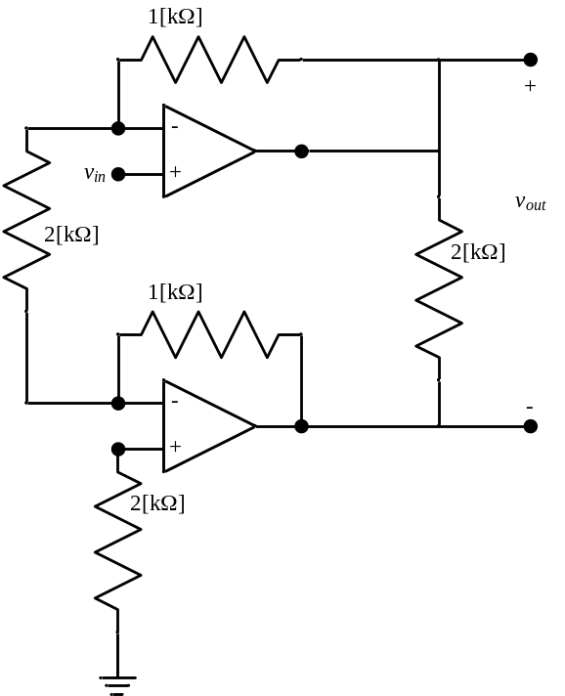
- 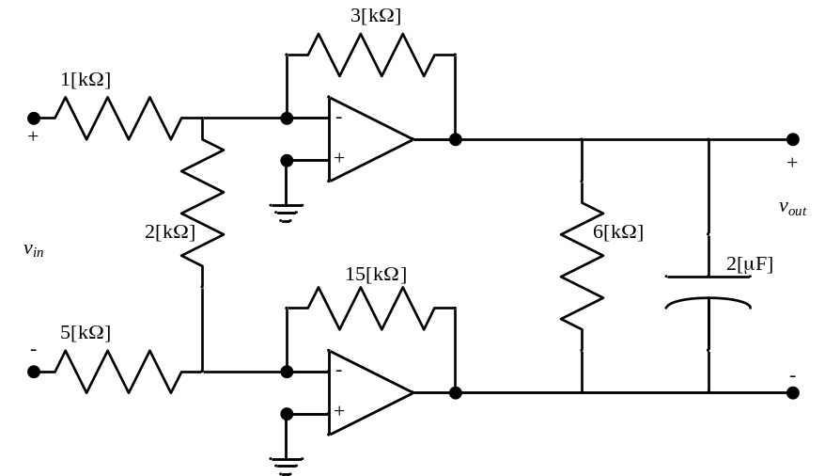

E5.2 The op amp in the circuit below is ideal. The switch is closed until t = 0, at which time it opens and stays open. Find v_{O}(t) for the range -10[s] < t < 10[s]. Assume that v_{IN}(t) = 2 sin(300[rad/s]t)[V].

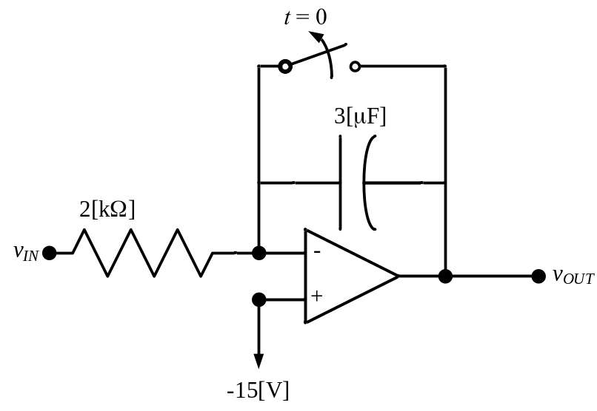

E5.3 a) Find the transfer function T(ω)=V_{o}/V_{i} for the op amp circuit below, assuming an ideal op amp.
b) Find the poles and zeroes for this transfer function.

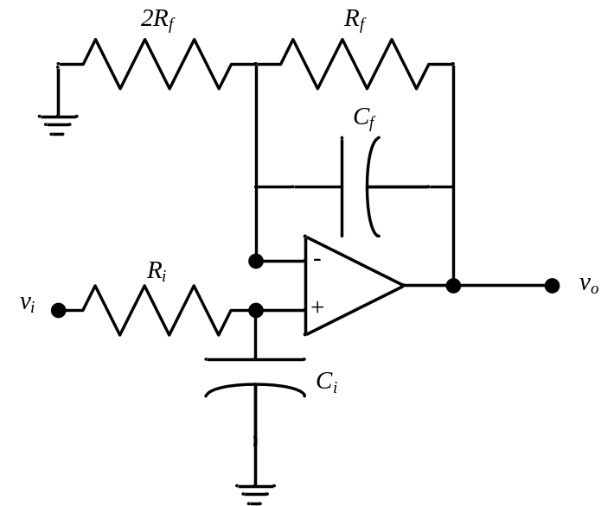

E5.4 Find the errors in the problem statements for the two parts of Problem 2.80 in the 8th Edition of Sedra and Smith. The errors have the same form. Explain how you would correct these errors.
Numerical Solutions:

2.8 a) -5, 20[kΩ]; b) -5, 20[kΩ]; c) -5, 20[kΩ]; d) -5, 20[kΩ]

2.32 a) I₁ = I₂ = 0.1 [mA]; I₃ = 10 [mA]; V_{x} = -1 [V]
b) max R_{L} = 1.19 [kΩ]
c) -11.1 [V] ≤ v_{o} ≤ -2.01 [V]

2.48 Solution omitted

2.69 Solution omitted

2.70 Solution omitted

Extra Problems:

5.1 a) v_{out}/v_{in} = 2; b) v_{out}/v_{in} = -3

  - v_{O} = (1.11[V] cos(300[rad/s]t) – 16.11[V] – 2500[V/s]t)

5.3 a) 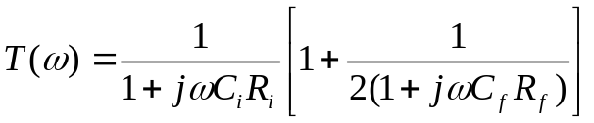; b) Solution omitted.

5.4 Solution omitted.

